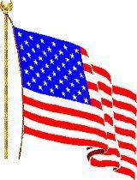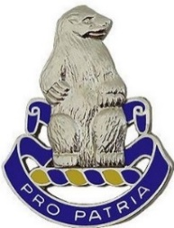**Pro Patria Press**

**#98**  **February 2021**

**Newsletter of the 31st US Infantry Regiment Association**

***Acting Editor: Ron Corson (jrcorson@aol.com)* _________________________________________________________________________________________**

**Reunion 2021 is Really Headed to the QUAD CITIES and This Time We’ll Make It !**

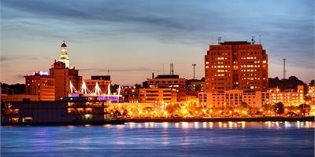2020 has finally passed and the COVID-19 vaccine is being administered across the country. As an old Soldier once said prior to a unit attack. “We’re at the bottom of the hill there’s no place to go but UP!” Well maybe he didn’t say that, but none the less 2021 promises to be better than this past year. It looks clear that our Reunion in September 2021 will be a **“GO.”** The Quad Cities located along the Mississippi will be a great place and this September will be a great time to reunite as Soldiers along with our families. Everything is set. All our members have to do is tear out Page 4, fill it out, and send it in to let everyone know: “This Polar Bear will be there.” So, our now long term Commander, Charlie Tapp, and the Board of Directors once again shout out: “**You All Come to Reunion 2021 in the Quad Cities on the Mississippi. You Hear?”**

**The New National Museum of the US Army Museum Opens at Fort Belvoir**

**and has Some Added History of the 31stUS Infantry**

The short article titled “The 31st Infantry Regiment” that begins at the top of Page 2 is the opening paragraph of the history of the 31st US Infantry Regiment on a plaque posted in the newly opened US Army Museum located at Fort Belvoir, VA. What is interesting is the added history of the Regiment, which is traced back to 1813, more than a century earlier than what the Association has listed as its recognized formation of the 31st US Infantry Regiment, on 13 August 1916 in Manila.

**Highlights in this Edition.**

The 31st Infantry - Page 2 Another Polar Bear Has Gone – Page 2 Reunion 2021 Itinerary - Page 3 Reunion 202 Registration Form - Page 4 The 4th Battalion SITREP - Page 5 TAPS and New Members - Page 6 Two Days during the Korean War - Page 7 Yes – Times Where Different - Page 7

A Few Combat Quotes - Page 8 Korean War Remains Returned - Page 8 Message from the Commander - Page 8 QM Store Order Form - Page 9

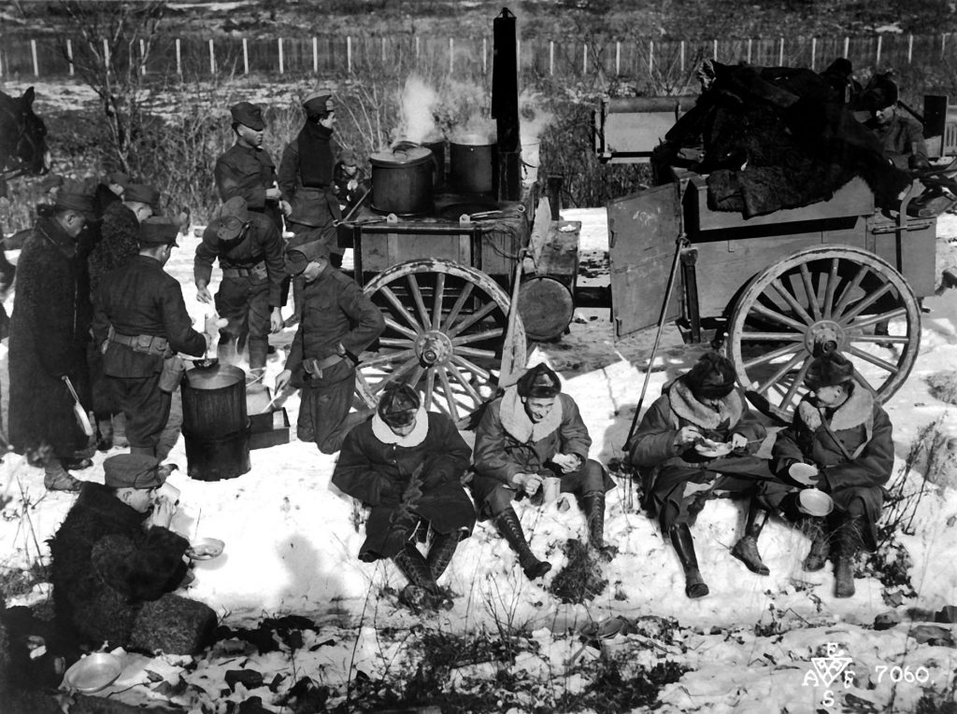**The 31st Infantry Regiment** **Written by: Patrick Feng**

In more than 100 years of service, the 31st Infantry Regiment has played a role in every major conflict and military operation involving the US Army from World War I to the Global War on Terrorism. Since 1813, three regiments have held the designation 31st Infantry.  The first was constituted on 29 January 1813 and consolidated with the Regiment of Light Artillery in 1815.  The second 31st Infantry was originally constituted 3 May 1861 as the 3d Battalion, 13th Infantry, and redesignated the 31st Infantry in September 1866.  It was then consolidated with the 22nd Infantry on 15 May 1869 and redesignated the 22nd Infantry.  The most recent unit designated 31st Infantry is one of a few Regular Army units constituted and organized outside of the United States.  Comprised of soldiers from the 8th, 13th, 15th, and 27th Infantry Regiments, the 31st was formed on 13 August 1916 at Fort William McKinley in Manila, the capital of the Philippines.

**Another Polar Bear Has Gone**

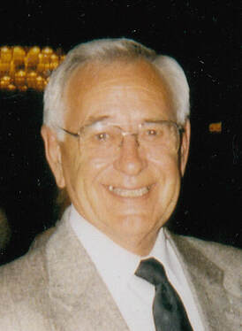On 20 July 2020, one of our Korean War veterans, a past commander of the Association, and long-time Northeastern Regional Director, Edwin “Ed” H. Bettis passed away. Ed grew up and lived his life in Skaneateles, NY. At the age of 17, in 1946, Ed enlisted in the Army and was trained as a Light Mortar Gunner. He was shipped to Italy and assigned to the 88th Infantry Division (Blue Devils). He served in the 350th and 351st Infantry Regiments carrying out guard duties and transporting of war prisoners. Ed attended the 88th Division’s NCO training and then reassigned to the 349th Infantry joining E Company on the Morgan Line where his squad held part of the line/border between Italy and Yugoslavia. When his enlistment was up, he was given an Honorable Discharge and placed in the Inactive Reserve. When the Korean War broke out in 1950, he was recalled to active duty and after a short refresher course was sent to the 3rd Infantry Division in North Korea (NK) and then on to the 7th Infantry Division. Ed fought in the Battle of the Chosin Reservoir. He survived Chosin and after being evacuated he was reassigned to G Company, 31st US Infantry Regiment. The War continued through the harsh winter of 1950 and 1951. In G Company, Ed was assigned to the mortar platoon and served as a Forward Observer. On 7 June 1951, G Company was given a mission to seize and secure a hill in the vicinity of Hanagok, NK. In mid-afternoon, G Company was hit with a misplaced napalm strike by US Navy planes. Ed was badly burned, evacuated to a MASH hospital, and spent two months in a hospital burn ward in Osaka, Japan. He returned to the States and was separated as a Corporal from the Army at the age of 21. In civilian life, Ed was very successful retiring in 1985, after 27 years, as Manager of Manufacturing for the Meade Paper Company. Ed had many passions including small sport cars, watercraft, scuba diving, and underwater search and recovery. Ed was a member of the “Chosin Few” and a member of both the Otisco Valley Memorial VFW Post 5494 and American Legion Post 239 in Skaneateles. In the mid 1980’s, Ed connected with the 31st US Infantry Regiment Association and brought his buddies from G Company into the 31st Association. Ed was the Northeast Regional Director, and in 1998, he was elected Commander of the Association. After his tour as Commander, he continued his role as the Northeast Regional Director. He maintained steady support and dedication to the POLAR BEARS of 4-31 at Fort Drum and the 31st Infantry Regiment Association. He will be sorely missed. **Pro Patria**

REUNION 2021 - QUAD CITIES – SEPTEMBER 18-21

**ITINERARY FOR REUNION 2021 – 31st US INFANTRY REGIMENT ASSOCIATION**

**DAY ONE: Saturday 9/18/2021**

*12:00-17:00: Registration open. Lobby. 2nd Floor Conference Center & QM Store Open Salon 1 2nd Floor.*

*12:00-17:00: Association Hospitality Room open. Retreat Room. 2nd Floor Conference Center.*

*16:00-20:00: Visit Quad Cities info booth Hallway 2nd Floor.*

*16:00-21:00: Dinner and time to explore on your own.*

**DAY TWO: Sunday 9/19/2021**

*07:00-09:30: Breakfast Served in the Rock Island Ale House.*

*10:00-11:00:* ***31st Infantry Memorial Service****. Salon 1 & 2. 2nd Floor Conf Center.*

*13:00-14:30 Board Meeting location TBD*

*11:00-21:00: Association Hospitality Room open. Retreat Room. 2nd Floor Conference Center*

*11:30-13:30: Lunch and time to explore on your own.*

*17:30-20:30: Welcome Cocktail Reception & BBQ Dinner - Grand Ballroom. 2nd Floor Conference Center.*

**DAY THREE: Monday 9/20/2021**

*07:00-09:30: Breakfast Served in the attached Rock Island Ale House.*

09:00: *Association Hospitality Room opens. Retreat Room. 2nd Floor Conference Center*

09:00-12:00: *Registration Desk & Welcome Table open. Lobby. 2nd Floor Conference Center.*

*09:00-10:30: General Membership Meeting. Salon 3. 2nd Floor Conference Center.*

*11:00-13:00: Lunch on your own.*   

*12:30-16:30: Rock Island Arsenal Tour. Meet in Lobby on the first floor by 12:15.*

*15:00-15:30:* ***Raffle Drawing & Silent Auction Final Hours*** *Registration Table.2nd floor Conference Center.*

*17:00-21:00: Celebration Belle Caption & Dance Cruise.*

*Meet at dock by 16:30 Address: 2501 River Drive Moline, IL 61265.*

**DAY FOUR: Tuesday 9/21/2021**

*09:00-11:00: John Deere Pavilion & Store. Meet at JDP by 8:45. Address: 1400 River Drive Moline, IL 61265.*

*17:30: Reception and Cocktails – Grand Ballroom 2nd Floor Conf Center*

*18:30: Posting of the Colors & Invocation, Dinner & Guest Speakers Grand Ballroom. 2nd Fr Conference Ctr.*

*20:30-22:00: The Shanghai Bowl Ceremony and Formal Toasts to the 31st US Infantry Regiment. Grand Ballroom. 2nd Floor Conference Center.*

**DEPARTURE DAY: Wednesday 9/22/2021**

*09:30-Whenever: The Goodbyes.*

Note 1: If you are registered at the hotel, breakfast is included

Note 2: Unless noted, all evening activities, off-site activities and Company Dinners are on your own

Note 3: Free time can be used for exploring the area or for Unit dinners

***See you at the next Association Reunion – Reunion 2022!***

Place and dates TBA based on member votes and changes to the Association Constitution.

**REGISTRATION FORM REUNION 2021** - **Rock Island, IL**

**31st US Infantry Regiment Association**

**September 18-21, 2021**

Name: _______________________________________________________________________________

Guest(s): _____________________________________________________________________________

Home Street Address: __________________________________________________________________

City: ______________________________________ State: _____________ ZIP Code: ______________

E-mail: ________________________________________ Phone: _______________________________

Company & Battalion of the 31st Infantry: ________________________ When: __________________

If active duty, Current Rank: __________________ Post stationed at: ___________________________

Served in Combat Zone: Yes / No (Circle) If Yes, where: _________________________________

Will you be staying at Holiday Inn Rock Island Yes / No (Circle)?

Have a car at the reunion? Yes / No If needed, are you willing to assist in local driving? Yes / No

**Reunion Activity Cost per Person X # Participating = Event Cost**

Reunion Registration $40 x _______ $ _________

Reunion Arrival Dinner $27 x _______ $ _________

Rock Island Arsenal Tour $15 x ________ $__________

Celebration Dinner Cruise $60 x ________ $__________

Reunion Banquet $40 x _______ $__________

John Deere Factory Tour $15 x _______ $__________

**Grand Total** **$ __________**

Make checks payable to**: 31st US Infantry Regiment Association**

**ATTN: Joe DeAngelis 3035 S. El Rio Dr., Meridian, ID 83642**

**Hotel and Travel Information: Total Cost is $85.00/night including tax and a Hot Breakfast every morning**

**Holiday Inn & Conference Center Quad City International Airport (MOL)**

**226 17th Street**  **Free airport / Hotel Shuttle**

**Rock Island, IL 61201** Moline Airport serviced by all major carriers. **www.holidayinn.com/rockisland**

**Reserve Room at (309-794-1212)**

**Suspense date for Hotel Reservations and Reunion 2021 Reservations is September 1, 2021**

**The 4th Battalion SITREP**

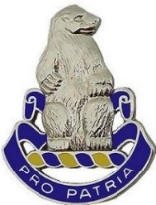**A Letter from the Commander**

**DEPARTMENT OF THE ARMY**

**4th BATTALION, 31ST INFANTRY REGIMENT**

**2nd BRIGADE COMBAT TEAM, 10th MOUNTAIN DIVISION**

**CAMP DWYER, AFGHANISTAN 09354**

To the Members of the 31st Infantry Regiment Association:

It has been a busy and exciting year for the Polar Bears. We welcomed many new soldiers, and executed a live fire progression that certified the 4-31st Infantry for deployment and combat operations.

Living up to our namesake of ***America’s******Foreign Legion****,* the Polar Bears deployed for the 10th time during the Global War on Terror, this time to Afghanistan in support of Operation Freedom’s Sentinel. Units were tasked with the tall order of replacing an entire Brigade’s worth of combat leaders throughout the theater. The Battalion then entered into a new era of the Polar Bears’ storied history. Throughout 2020, the Battalion had to adapt and overcome obstacles related to the COVID-19 pandemic. We proved once again that Polar Bears will remain ready regardless of the operational environment. The Polar Bears have received praise from all levels of command for our seamless transition into this unique mission set.

Not to be outperformed, our Home Station Mission Command team at Fort Drum has developed a robust training program to ensure all Polar Bears are trained, certified and ready to deploy. Overall, the Polar Bears have continued the time-honored tradition of excellence, upheld since the Regiment’s inception in 1916.

We look forward to returning home and continuing the Climb to Glory.

***Pro Patria!***

CHRISTOPHER M. ROWE

LTC, IN Commanding

Note: Camp Dwyer, Helmand Province, the current duty station of the 4-31 Polar Bears, was named after British Lance Bombardier James Dwyer (1984-2006), of the 29th Commando Regiment Royal Artillery. He was killed on 27 December 2006, age 22, when the vehicle he was driving struck an anti-tank mine while on a patrol in southern Helmand Province. Camp Dwyer was originally a forward operating base (FOB), in May 2009 it was expanded into a Camp by Naval Mobile Construction Battalion Five (NMCB 5).

**TAPS**

**Deceased members** **identified since Newsletter # 97, Oct 2020**

**PRE-KOREAN WAR**

Melvin A. Bates, CPL, Lincoln, NE, died Nov 26, 2020, I & R, HHC, Rgt, 1946-1948

**KOREA WAR**

George W. Conrad, CPT, Leander, TX, died Nov 10, 2020, Cos E & F, 2nd Bn, 1952-1953

Stanley E. Cutlip, MSG ret, Sutton, WV, died Dec 2, 2020, Co I, 3rd Bn, 1950-1952

Homer P. Erickson, CPL, Boise, ID, died Oct 8, 2020, Co K, 3rd Bn, 1951-1952

Charles G. Huch, LTC Ret, Bethlehem, PA, died Dec 31, 2020, Co E & Svc, 2nd Bn & Rgt, 1953-1954

Robert E. Hoffman, SFC, Alturas, CA, died Sep 13, 2015, Co K, 3rd Bn, 1952

Matthew F. Sokoloski, CPL, Mims, FL, died Sep 11, 2020, Co L, 3rd Bn, 1950-1951

Elliott Sortillo, SGM ret, Cypress TX, died Jan 1, 2021, Cos B & HHC, 1st & 2nd Bns, 1950-53, 1968-69

John J. Zitelberger, COL ret, Midland, GA, died Jun 19, 2020, HHC, 2nd Bn, 1950-1951

**POST KOREAN WAR**

Larry A. Damour, Sr., SP4, Weare, NH, died Aug 17, 2018, Co C, 1st Bn, 1969-1970

**VIETNAM**

Rene F. Nawodylo, SGT, Chicago, IL, died Dec 29, 2020, Co A, 4th Bn, 1965-1967

**ASSOCIATE**

Donald Beets, Warrensburg, MO, died Sep 8, 2020. Brother of PFC Wayne Drake, died in a POW Camp, Philippines

Dona R. Seppelfrick-Spencer, Aurora, IL, died Dec 2, 2020, widow of MSG ret James M. Spencer Sr.

NOTE: There were no deceased members reported from World War II or USA eras

**NEW MEMBERS**

William D. Blackburn, PFC, Roanoke, VA, Co A, 1st Bn, 1950

Ashley Sanderson-Sweetz , Lakeland, FL, granddaughter of Richard A. Stephenson, SP4, Co C, 6th Bn, 1969

Michael Sanderson, Winter Haven, FL, grandson of Richard A. Stephenson, SP4, Co C, 6th Bn, 1969

**Two Days during the Korean War, Two Medals of Honor**

In its 104-year history, seven members of the 31st Infantry Regiment have earned the Medal of Honor—five during the Korean War and two in Vietnam. Two of those Medals were earned on two successive days during Korea’s Operation Showdown. Only one of the two Polar Bears lived to receive the Award.

On 14 October 1952 the 31st Infantry Regiment launched Operation Showdown to take Triangle Hill as part of an 8th Army push to seize the entire Iron Triangle. Two days of air strikes to prep the battle area were followed on 14 October by a rolling barrage from the 280 artillery pieces of the US IX Corps. But the Chinese 15th Corps troops were deeply dug in and had a covered tunnel system to feed replacements to the front as US firepower devastated their front-line soldiers. The result was that the Polar Bears suffered their heaviest single day of casualties during the Korean War with 97 KIAs and 337 WIAs.

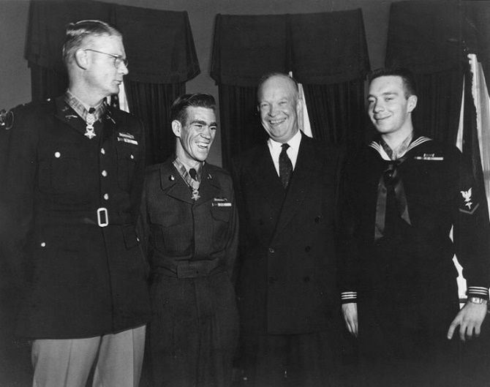

1LT Edward R. Schowalter, commanding A Company, 1st Battalion, spearheaded the attack that first day against the fierce Chinese resistance. LT Schowalter received two grazing wounds to his hand and ankle before being shot in the helmet by a sniper. The bullet lodged under the skin in his right ear and knocked him unconscious. When he awoke, he refused medical attention and resumed leading his soldiers forward. When he was wounded in the right side by a grenade, he again turned away medical aid and continued to command A Company until the hill was taken. For his actions that day, Schowalter was awarded the Medal of Honor by President Eisenhower (Captain Schowalter is on the left in the picture).

Next day, 15 October, the action was just as intense. PFC Ralph Pomeroy, a machine gunner in E Company, was covering the consolidation of the objective by his company, inflicting heavy casualties on the counterattacking enemy in the process. The Chinese soon brought artillery and mortar fire on Pomeroy’s position, but he maintained his stance and continued to inflict heavy casualties on the enemy. Then a mortar round severely wounded him and left his gun mount inoperable. He removed the hot weapon from the wrecked mount and cradling the weapon in his arms continued firing. He was wounded again but went on firing until he ran out of ammunition. Even then he pressed on, closing with the enemy and using the machine gun as a club until he was mortally wounded. Army Secretary Robert Stevens presented the Medal of Honor to Pomeroy’s parents on 16 December 1953, for their son’s “inspirational actions and supreme sacrifice.” **Pro Patria**.

**Yes - Times Were Different**

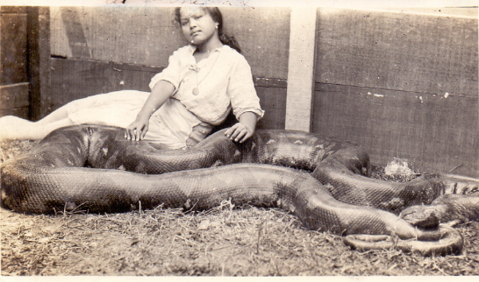In the 1920’s and 30’s, life for soldiers and for families in the 31st in Manila was not the same. Newly enlisted soldiers arrived in the Regiment with no military training. The Regiment was totally responsible for turning young civilians into Infantry Soldiers. While life for American families was good, in many ways there were a number of things that were just a bit different, such as keeping the quarters rodent free. As shown in the picture, a Philippines rodent control device (the python) for 31st Infantry family quarters during the 1920’s.

**A Few Combat Quotes for Old Soldiers and Their Leaders**

“If the enemy is in range, so are you.” - Infantry Journal

“Tracers work both ways.” - Army Ordnance Manual

"Try to look unimportant; they may be low on ammo." - Infantry Journal

"Bravery is being the only one who knows you're afraid." – COL David Hackworth

“If you see an EOD specialist running from a site, try to keep up with him.”- Anonymous

**Korean War Vet Remains Returned**

October 2020 - The remains of an Erie, PA soldier killed during the Korean War have been brought home for burial after 70 years. Army PFC Harold K. Knight was buried at Heckathorn Cemetery in Seneca, PA, His remains were turned over to the United States by North Korea in 2018 and were identified by DNA analysis and circumstantial and material evidence in 2019.

Knight was assigned to Headquarters and Headquarters Company, 31st Infantry Regimental Combat Team, in Korea. He was killed in action on 25 November 1950. His unit of the 31st US Infantry was engaged in several days of intense fighting against the Chinese People's Volunteer Forces at Sinhung-ri, near the Chosin Reservoir in North Korea.

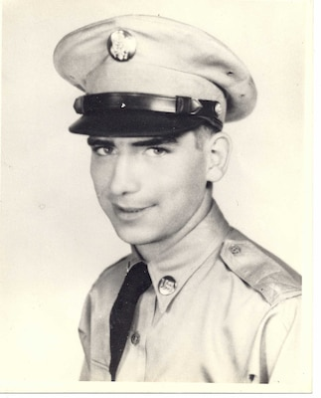

PFC Knight was 20 years old. His body could not be recovered following the battle. Knight's name is recorded on the Courts of the Missing at the National Memorial Cemetery of the Pacific in Honolulu, along with the names of others still missing from the Korean War. A rosette will be placed next to his name to indicate he has been accounted for by the Defense POW/MIA Accounting Agency. More than 7,600 Americans remain unaccounted for from the Korean War. PFC Knight was the fifth of 12 children. Three of his siblings survive, Frances Thompson, Albert Knight and Patricia McInchak.

*PFC Harold K. Knight*

**A Message from the Commander: Light at The End of The Tunnel**

It has been a long trying year for our country but just as all soldiers we are persevering. We now have a vaccine that appears to enable us to get past the pandemic. Never in history has a vaccine been produced in such a short time. It has been a hard time, but we have and will continue to be the greatest nation in the world. May we all as good soldiers work to keep us the greatest nation in the world.

Let’s now begin to make plans for a great Reunion. The Quad City Visitor’s Bureau is promising to welcome us with the Midwest hospitality that they are known to hand out. They are all excited, as we will be to be there. I cannot say enough about how the Visitor’s Bureau has stayed in touch and wanting to welcome you to their historical area. See you in the Quad Cities in September.

**Pro Patria, Charlie Tapp**

**31st INFANTRY REGIMENT ASSOCIATION QUARTERMASTER STORE ORDER FORM**

***Visit 31stinfantry.org and click on 31st Infantry Store to see a full color catalogue of these and many more items***

**Name:________________________________________________ Telephone #____________________________________________**

**Address:_____________________________________________________________________________________________________**

**City:_______________________________ State:_____________ Zip:___________ Email:__________________________________**

**Cat # Description ­_____________ Price Qty Total**

**B 102 Book, 31st Infantry Regiment “America’s Foreign Legion” In peace and war (Includes shipping)**

**Do not include this in shipping cost at bottom of form $ 40.00 X___=________**

**C 100 Coin, Commemorative, 100th Anniversary (if you order 10 or more the price is $8.00 each). $ 10.00 X___=_______**

**C100AT Airtight capsule for 100th Anniversary Commemorative coin $ 1.50 X___=_______**

**C100EB Easel, black *both the black and clear easels are for Airtight capsule with 100th* $ 1.50 X___=_______**

**C100EC Easel, clear *Anniversary Commemorative coin or the Commemorative coin alone* $ 1.50 X___=_______**

C RB 02 **Cap, Royal Blue**, 31st INFANTRY REGIMENT, POLAR BEARS, and crest embroidered directly **$ 15.00 X ___=_______** directly on cap and US ARMY embroidered on back.

C RB **Cap same as C RB 02** above with the addition of a waving U.S. flag on the left side and a combat

patch (Philippines Division; 7th Infantry Division; 196th Light Infantry Brigade; 9th Infantry Division;

10th Mountain Div) on the right side. **Circle the patch you want. $18.00 X___=_______**

C K ***NEW CAP!*** same as C RB above but in **Khaki** with a waving U.S. flag on the left side and a combat patch

*(Philippines Division; 7th Infantry Division; 196th Light Infantry Brigade; 9th Infantry Division.*

*10th Mountain Division)* on the right side. **Circle the patch you want**)**.** All embroidery is subdued. $18.**00 X___=_______**

SP Shirt, Polo/golf w/31st INFANTRY REGIMENT and polar bear crest on left chest, **no pocket**

**Please circle color and size.** Size: S, M, L, XL White, Light Blue, Navy Blue **$ 29.00 X___=_______**

Size: 2XL White, Light Blue, Navy Blue **$ 31.00 X___=_______**

**SP100 Same as above with 100th Anniversary logo in White only** Size:S, M(Sold out), **L, XL $ 31.00 X___=_______**

Size: 2XL  **$ 33.00 X___=_______** Size:3XL **$ 35.00 X___=_______**

ST Shirt, Tee, w/31st INFANTRY REGIMENT and polar bear crest on left chest, **no pocket**

**Please circle color and size.** Size S, M, L, XL Light Blue, Navy Blue **$ 16.00 X___=_______**

Size 2XL Light Blue, Navy Blue **$ 19.00 X___=_______**

Size 3XL Light Blue, Navy Blue **$ 21.00 X___=_______**

SLSVC Shirt, Long Sleeve, Dress in various colors w/31st INFANTRY REGIMENT and

polar bear crest on left chest above pocket. **Please circle color and size** Size: S, M, L, XL **$ 30.00 X ___=_______**

Colors: Black, Navy Blue, Light Blue, Red, White, Texas Orange, Burgundy, Size 2XL **$ 32.00 X___=_______**

**or Denim** Size 3XL **$ 36.00 X___=_______**

MS 01 Shanghai Bowl Cup, silver, 2007 reproduction of original. (Includes shipping)

**Do not include this in shipping cost at bottom of form** **$165.00X___=_______**

DCL 01 Bumper sticker, 31st Infantry crest (Polar Bear), 4-3/8” tall, 4-1/4 wide **$ 3.00 X___=_______**

PN 01 Pin, 31st Infantry Regimental crest (Polar Bear), regulation size, facing set. **$ 8.00 X___=_______**

PN 02 Pin, 31st Infantry Regimental crest (Polar Bear), lapel/hat pin. 7/8” tall, ¾” wide **$ 4.00 X___=_______**

PN 73 Pin, Combat Infantry Badge, lapel/hat pin. 3/8” tall, 1-1/4” wide **$ 3.00 X___=_______**

PN 74 Pin, Combat Infantry Badge, regulation size, 1-1/4” tall, 3” wide **$ 4.00 X___=_______**

PN 82 Pin, Purple Heart, lapel/hat pin. 1-1/8” tall, 5/8” wide **$ 3.00 X___=_______**

PN 85 Pin, Silver Star, lapel/hat pin. 1-1/8” tall, 5/8” wide **$ 3.00 X___=_______**

PN 71 Pin, Bronze Star, lapel/hat pin. 1-1/8” tall, 5/8” wide **$ 3.00 X___=_______**

**Shipping Charges** – add to your order: Orders under $10.00 add $2.50; For orders $10.01 - $25.00 **SUBTOTAL $_________**

add $6.00; For orders $25.01 - $50.00, add $7.00; For orders over $50.00, add $9.00. **SHIPPING** **$_________**

**Grand TOTAL $_________**

MAKE CHECK OR MONEY ORDER PAYABLE TO: **31st INFANTRY REGIMENT ASSOCIATION**

**For Credit Cards (American Express, Discover, Master Card, or Visa) or Debit card (with Master Card or Visa logo)** please include

**NAME** (on card):___________________________________ **CARD #:________________________________EXP DATE:_____/_____**

**SECURITY CODE**(on back of card): ____________ **ZIP CODE** (where credit card bill is mailed to):_____________________

**Mail the order form and payment to**: **Dale Mills 337 Carillon Lane, Macon, GA 31210-9711**

**Association Officers**

**Honorary Colonel of the Regiment Robert “Sam” Wetzel LTG Ret** (LTC, Cdr, 4th Bn, VN 1968)

1425 Dartmouth Rd, Columbus, GA 31904 706-576-4204 wiint322@aol.com

**Commander**: **Charlie Tapp** (SSGT, D-6th Bn, VN, 1970)

215 Waterford Drive, Inman, SC 29349 864-473-1999 ctapp94@gmail.com

C 864 680-9165

**Vice Commander**: **Dan Wood** (CSM/4th Bn, Ft. Drum, 2000-02)

1484 McGill Road, Vass, NC 28394 910-633-8397 wooddr3@gmail.com

**Adjutant**: **Vin Zike** (SGT, D-6th Bn, VN, 1969-70)

9676 159th Ct N, Jupiter, FL 33478 914-850-0095 vinzike@gmail.com

**Treasurer: Joe DeAngelis**  (SGT,C/6th Bn, Ft Lewis & VN, 1967-69)

3035 South El Rio Dr., Meridian, ID 83642 208-362-9468 jangels10@gmail.com

**Membership**: **Jim Tierney**  (SSG, A-6th Bn, VN, 1969-70)

1484 Loretta Dr., Penn Hills, PA 15235 412-793-7214 jtier64999@aol.com

**Quartermaster**: **Dale Mills** (SGT, C-6th Bn, VN, 1967-69)

337 Carillon Lane, Macon, GA 31210 478-787-2679 sdalem@bellsouth.net

**Sergeant at Arms**: **Jim Jaggers** (SGT, B-6th Bn, VN, 1968-69)

5638 Camellia Ave, Sacramento, CA 95819 916-455-7879 jim@jaggers.me

C 916 802-7750

**Historian: Grady Smith** (CPT, D-6th Bn, Ft Lewis & VN, 1967-68)

2321 S. Queen St, Arlington, VA 22202 703-769-2778 smithga@verizon.net

C 703 927-6261

**Senior Director: Ron Corson** (CPT, A-6th Bn, VN, 1969-70)

108 Mershon Way, Williamsburg, VA 23185 757-253-1311 jrcorson@aol.com

**Northeast Region (**ME, NH, VT, MA, RI, CT, NY) **Ivan Barker III** (1st SGT, F & HHC-4th Bn, Ft Drum, 2012-17)

3127 Cataract St, Copenhagen, NY 13626 315-286-7696 barker_ivan@hotmail.com

**Mid-Atlantic Region** (NJ, PA, DE, MD, DC, VA, WV) **Jim Simms** (LT, C & HHC-4th Bn, VN, 1969-70)

104 Cumberland Dr., Carlisle, PA 17013 717-243-5570 jnpsim@comcast.net

**Southeast Region** (NC, SC, GA, FL, AL, MS, TN, AR, LA, PR, VI) **Noah Halfacre** (LT, E-6th Bn, VN, 1970)

1116 Dundee Ct, Murfreesboro, TN 37129 615-892-9246 gimlet3a@gmail.com

**Great Lakes Region** (KY, OH, MI, IN, IL, WI) **John Howdeshelt** (SGT, D-6th Bn, VN, 1969)

788 Eagledale Circle, Kettering, OH 45429 937-435-0669 mamahowdy@yahoo.com

**Midwest Region** (MN, ND, SD, NE, IA, MO, KS, OK, TX, NM, CO) **John Mansfield** (LT, A&B-4th Bn, VN 1967-68)

3100 Chambers St, Sioux City, IA 51104 712-277-4498 arctic6@aol.com

**Western Region** (HI, AK, WA, OR, CA, NV, AZ, UT, ID, MT, WY) **Ron Belloli** (LT, C-6th Bn, VN, 1967-68)

1250 American Pacific Dr, Apt 214, Henderson, NV 89074 928-380-9577 ronbob22631@gmail.com

**. . . . . . . . . . . . . . . . . . . . . . . . . . .**

**NEWSLETTER CHANGE OF ADDRESS**

Cut along dotted line. Fill in requested information and mail to The Membership Chairman, address below.

or EMAIL Jim Tierney with this information at jtier64999@aol.com **SUBJECT: CHANGE OF ADDRESS**.

Name: ________________________________________ Phone number if new: ______________________________

Old Address New Address Mail To:

___________________________ __________________________ Jim Tierney, Membership Chairman

Street or P.O. Box Street or P.O. Box 1484 Loretta Drive

___________________________ __________________________ Penn Hills, PA 15235

City/State/Zip City/State/Zip

**Membership Application – 31st US Infantry Regiment Association**

First Name Nickname Middle Initial Last Name

Street Address City State Zip Code Phone Number

E-mail address Alternate E-mail Address

Please fill in as much information about your service/connection with the 31st Infantry Regiment as possible:

Platoon__________ Company Battalion

________

Highest Award Earned

Rank & Duty Position when serving with the 31st Regiment Rank When Retired/Separated

**Where did you serve with the 31st? When?**

Philippines __________ _______________________________________

Japan __________ _______________________________________

Korea __________ _______________________________________

Vietnam __________ _______________________________________

Iraq __________ _______________________________________

Afghanistan __________ _______________________________________

Other Overseas __________ _______________________________________

USA __________ _______________________________________

**Membership Desired**

**Life Membership**

Active Duty __$25

Age 49 & under __$60

Age 50 – 59 __$45

Age 60 & over __$35

Associate Life __$25

Member (family)

Make your check out to **31st Inf Regt Assn** and mail it to our Membership Chairman:

**Jim Tierney, 1484 Loretta Drive, Penn Hills, PA 15235.**

**31st Infantry Regiment Association**

**Jim Tierney**

**1484 Loretta Drive**

**Penn Hills, PA 15235**

**Newsletter 98**

### RETURN SERVICE REQUESTED

**If the Addressee no longer**

**lives at the below address**

**Please RETURN this to the above**

**Mark YOUR CALENDARS FOR REUNION 2021**

**Quad Cities, IL/IA 18-21 September 2021**

